**Factors Influencing Fire Behavior**

**in Mountain Longleaf Pine Restoration Sites**

Mountain longleaf pine (LLP) communities are rare, occurring in the Piedmont and Ridge and Valley Regions in Georgia and Alabama. Restoring these sites with frequent prescribed fire is a high priority. Mountain LLP occurs in mixed composition stands with other pines and pyrophytic hardwoods (oaks and hickories); mesophytic hardwoods have also established on these sites. Research over the past decade has shown that the flammability of leaf litter varies substantially among southeastern tree species. To better understand factors that affect fire behavior, and ultimately restoration success on mountain LLP sites, a research team from Kennesaw State University and Auburn University conducted a study within operational burn units in Georgia. The team hypothesized that simple measures of stand composition and structure (basal area, proportion of pyrophytes vs. mesophytes) would be related to fire behavior. Stands with lower basal area and fewer mesophytes would burn more intensely because of the fuelbed structure and flammability. Similarly, they predicted that sites with litter fuelbeds dominated by pyrophytic species (pines and oaks) would burn more intensely than sites with more mesophytic litter. They also wanted to know whether direct measures of litter structure (loading, bulk density) were closely related to stand structure and composition and were necessary to predict fire behavior at the plot-scale. The findings were recently published in the journal *Forest Ecology and Management* “Variations in stand structure, composition, and fuelbeds drive prescribed fire behavior during mountain longleaf pine restoration” (authors: Collin Anderson, Matthew P. Weand, Heather Alexander, Mario Bretfeld, and Nicholas Green).

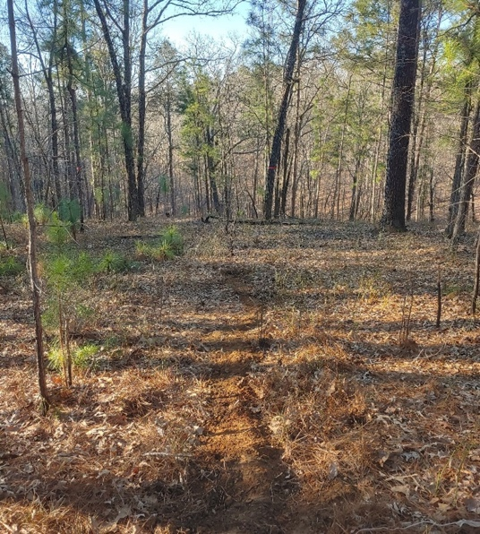

Open canopy, pine and pyrophytic hardwood dominated stands before a prescribed burn. Taken 3 March 2022 at 8:32am

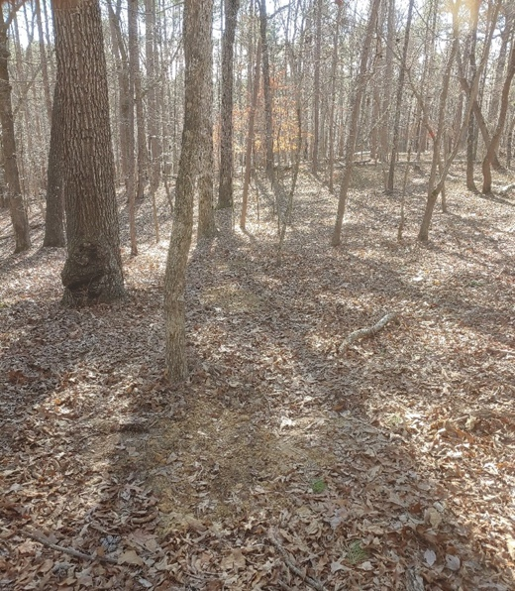

Closed canopy, mesophytic hardwood dominated stands before a prescribed burn. Taken 8 February 2022 at 10:17am

**Study Site:**

* The study occurred in the [Sheffield Wildlife Management Area](https://georgiawildlife.com/sheffield-wma) in Paulding County, GA. Mountain LLP occurs in stands that are mixed with other pines, oaks and hickories, and encroaching mesophytes.
* Study plots were established in five prescribed burn units and the team measured stand structure and composition and litter fuels (loading, bulk density, species composition) prior to the prescribed fires.

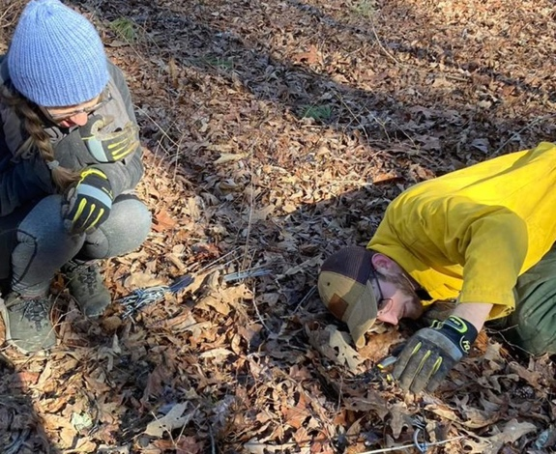

Collin Anderson and Becca Senft recording fuel depth before a prescribed burn.

* Prescribed burns were conducted in February and March 2022. Thermocouples were deployed in the plots to estimate several measures of fire behavior (maximum temperature, rate of spread, residence time). Litter and duff depth were also measured after prescribed fires to estimate consumption.

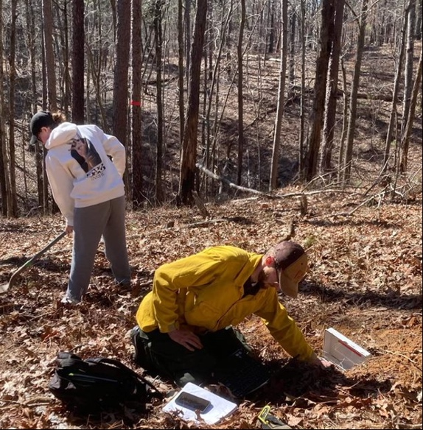

Collin Anderson preparing data loggers for fire behavior measurements before a prescribed burn.

* The authors used the statistical method of path analysis to examine relationships between stand structure and composition, litter composition, fuel structure (loading, bulk density), and fire behavior.

**Key Findings:**

* As predicted, fire behavior was significantly related to stand structure and tree species composition, with more intense burning occurring where stand basal area was lower and pines and pyrophytic hardwoods (oaks) were strongly dominant compared to mesophytes.
* As predicted, sites where litter beds were strongly dominated by litter of pyrophytes (pines and oaks) burned more intensely compared to sites with a higher proportion of mesophyte litter.
* Unexpectedly, however, the structure of the fuel beds (loading, bulk density) measured on the plots was not strongly related to either stand structure and composition or to the species composition of the litter. The authors suggest that the rapid decomposition of mesophytic litter during the winter months made it more difficult to relate stand and litter composition to fuel loading.
* From a management perspective, this study provides evidence that simple measures of stand composition and structure can be useful for predicting fire behavior when there are mixtures of pyrophytes and mesophytes. The results also highlight the importance of flammable pyrophytic hardwood litter to promote fire, even though the focus is on the restoration of mountain longleaf pine communities.

**Link to Paper:**

Collin J. Anderson, Matthew P. Weand, Heather D. Alexander, Mario Bretfeld, Nicholas Green. Variations in stand structure, composition, and fuelbeds drive prescribed fire behavior during mountain longleaf pine restoration. *Forest Ecology and Management*, Volume, 575, 2025.

[**https://doi.org/10.1016/j.foreco.2024.122372**](https://doi.org/10.1016/j.foreco.2024.122372)

[**https://www.appalachianfire.org/_files/ugd/696505_968f4ac3fabd48129e6112483f850482.pdf**](https://www.appalachianfire.org/_files/ugd/696505_968f4ac3fabd48129e6112483f850482.pdf)

**About the Author:** Collin Anderson did his MS degree at Kennesaw State University and has since taken a job in environmental consulting.